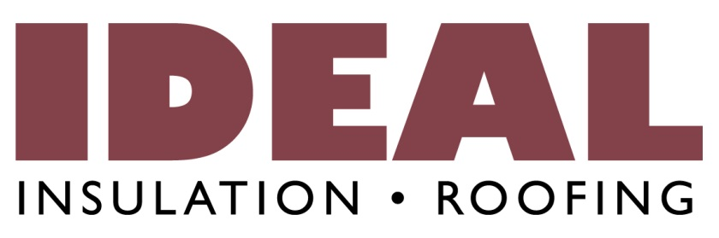

Wanted: Construction Estimator
IDEAL Insulation & Roofing is excited to offer an Estimating position available immediately in our engaging, team-based contracting business. IDEAL is a leader in Alberta’s contracting industry and we are looking for strong individuals to join our team.
IDEAL is a customer service oriented business. We are driven to maximize profits through excellence in our activities. Our future growth is built on the foundation of knowing that our services are second to none. In applying for a job at Ideal, you recognize that we do everything we can to maximize the value we provide both to our customers and to the end users of our services. Both the culture that we continue to build and the team members already here will demand this of you. Part of that culture is looking after our team members, therefore a generous benefits package is made available.
You will be rewarded for your hard work and creative thinking with the opportunity to grow both personally and professionally. As well as, financially and by working with a great team and engaged customers. You are the right candidate if you are dedicated to quality, thoughtful, eager to learn and above all else accurate. A focus upon doing the right thing for our customers, staff and organization supported by a whatever it takes attitude will be valued above all else. Experience in construction counts, but most of all you need to have passion, responsibility and pride in what you do.
We are growing, and we are looking for dedicated people that want to grow with us.
If this sounds like you, please contact us today. Please have your resume and references ready.

